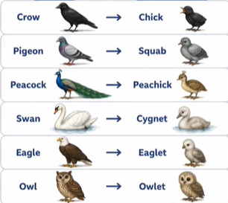
BIRDS AND YOUNG ONE IMAGES

